Preparations of Papers for the JLTR Journal of Academy Publication: A New Version (August 2024)*

Firstname M. Lastname
Department/division, Name of Institution, City, Country

Firstname M. Lastname
Department/division, Name of Institution, City, Country

Abstract—Submitted manuscripts should be between 4000 and 8000 words (including references and appendices). In the paper title, all words of four letters or more should be capitalized. In the abstract, there should be no more than 250 words (as a single paragraph). These instructions give you basic guidelines for preparing camera-ready papers for AP’s journals. Please read the instructions carefully.

Index Terms—first term, second term, third term, fourth term, fifth term

I. Introduction
Your goal is to simulate the usual appearance of papers in a journal of the Academy Publication. We are requesting that you follow these guidelines as closely as possible.
A. Full-Sized Camera-Ready (CR) Copy
Paper size: prepare your CR paper in full-size format, on A4 paper (21 x 29.7 cm).
Margins: top = 3 cm, bottom, left and right = 2 cm.
Type sizes and typefaces: Follow the type sizes specified in Table 1. Times New Roman has to be the font for main text. Papers should be single spaced.

Table 1
Type Sizes for Camera-Ready Papers
Type size (pts.) | Appearance
Type size (pts.) | Regular | Bold | Italic
6 | Table superscripts, figure superscripts
8 | Tables, table names, table captions, figure captions, footnotes, text subscripts and superscripts
9 | References, authors’ biographies | Abstract, index terms
10 | Authors’ affiliations, main text, equations, section headings, appendices, acknowledgements |  | Subheadings
11 | Authors’ names
24 | Paper title

Paragraph indentation: first-line 0.37 cm. For Abstract and Index Terms, left and right indentations are 1 cm, with no first-line indentation.
Alignment: left- and right-justify your column. Use automatic hyphenation and check spelling. Digitize or paste down figures.
Paragraph spacing: should be single spaced, no space between paragraphs (0 line before and after), do not snap to grid (see Figure 1).

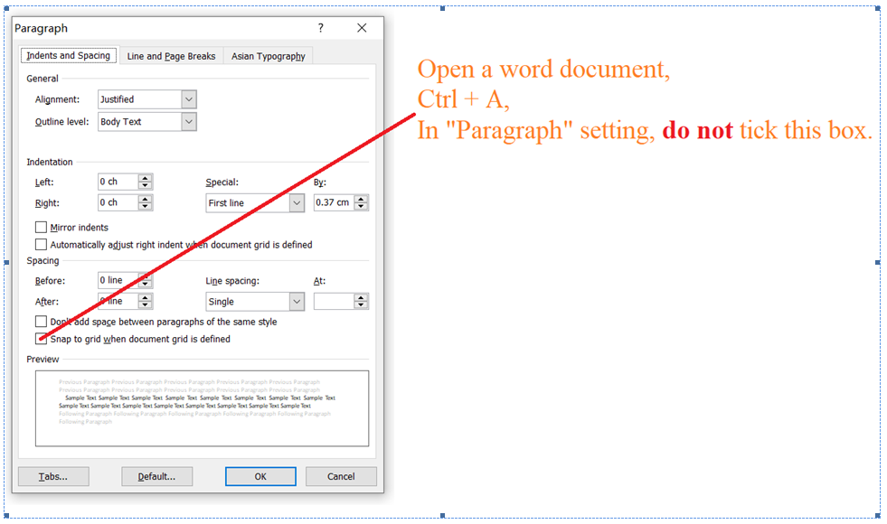
Figure 1 Paragraph Setting in a Word Document

Title: use 24-point Times New Roman font. Its paragraph description should be set so that the line spacing is single with 6-point spacing before and 6-point spacing after.
Section headings (Level 1 Heading): each major section begins with a heading in 10 point Times New Roman font centered within the column and numbered using Roman numerals (except for Acknowledgements and References), followed by a period, two spaces, and the title using an initial capital letter for each word. The remaining letters are in small capitals (10 point). The paragraph description of the section heading line should be set for 12 points before and 6 points after.
Subheadings (Level 2 Heading): should be 10 point, italic, left justified, and numbered with letters (A, B, …), followed by a period, two spaces, and the title using an initial capital letter for each major word. The paragraph description of the subheading line should be set for 6 points before and 3 points after.
B. An Example of Level 2 Heading
(a). An Example of Level 3 Heading
1. An Example of Level 4 Heading
(1). An Example of Level 5 Heading
Please note, there should be at least two headings at the same level (whether it is Level 1 or Level 5).

II. Helpful Hints

A. Figures and Tables
Figure captions should be centered below the figures; table captions should be centered above. Avoid placing figures and tables before their first mention in the text.
For figure axis labels, use words rather than symbols. Do not label axes only with units. Do not label axes with a ratio of quantities and units. Figure labels should be legible, about 8-point type.
Color figures will be appearing only in online publication. All figures will be black and white graphs in print publication.

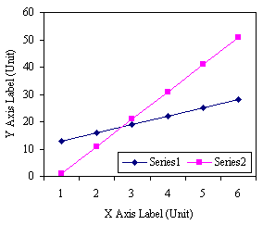
Figure 2 Note How the Caption Is Centered in the Column

B. In-Text Citations
This journal uses an author-date citation system that is based on APA style, which basically contains author’s last name / surname and the date (year) of publication. Below are some examples:
Miguel and Carney (2022) found that we could provide opportunities for immediate feedback by using project-based learning.
We could provide opportunities for immediate feedback by using project-based learning (Miguel & Carney, 2022).
When there are three or more authors, use the first author’s last name/surname plus “et al.”
Kaharuddin et al. (2022) examined the effects of task-based language teaching.
Task-based language teaching can produce positive effects in writing descriptive texts (Kaharuddin et al., 2022).
Page number should be mentioned when there are direct quotations.
Miguel and Carney (2022) found that the use of project-based learning “provided opportunities for immediate feedback” (p. 5).
The use of project-based learning “provided opportunities for immediate feedback” (Miguel & Carney, 2022, p. 5).
When a direct quotation has less than 40 words, it is run into the text and enclosed in quotation marks. When a direct quotation has 40 words or more, it is treated as a block quotation:
A block quotation begins on a new line, and no quotation marks are used. The whole block is indented 1.27 cm from the left margin. If the sentence preceding the block quotation is a complete sentence (as in this example), it is ended by a colon and the first word in the block quotation uses a capital letter; if the sentence preceding the block quotation is part of a sentence (not a complete sentence), it is followed by a comma and the first word in the block quotation uses a small letter. (JLTR template, 2024)
A passage, after being summarized /paraphrased /reworded/ rewritten, might not be detected as “similar” by a piece of plagiarism-checking software. However, as the ideas or facts are borrowed, credit must be given to the original source /work.

C. References
All the works cited in the text / paper should be listed in References. Number the references consecutively in square brackets [1]. No punctuation follows the bracket.
In References, list all authors’ names if there are less than 21 authors. Papers that have been submitted but not yet accepted for publication should be cited as “unpublished manuscript”. Papers that have been accepted for publication but not yet published should be cited as “in press”. For a reference that is not in English, if the original language also uses the Roman alphabet (for example, Dutch, French, German, Spanish), first give the original language, then the English translation in square brackets; if the original language doesn’t use the Roman alphabet (such as Arabic, Chinese, Japanese, Korean, Russian), first transliterate it into Roman alphabet, then the English translation in square brackets. For online references, a URL and retrieval time must be given.
At the end of each reference, give the DOI (Digital Object Identifier) number as long as available, in the format as “https://doi.org/10.17507/jltr.1205.01”

D. Footnotes
Number footnotes separately in superscripts ^{1, 2, …}. Place the actual footnote at the bottom of the page in which it is cited. See first page footnote for an example.

E. Abbreviations and Acronyms
Define abbreviations and acronyms the first time they are used in the text, even after they have been defined in the abstract. Do not use abbreviations in the title unless they are unavoidable. The abbreviation “ibid.” is not used.

F. Equations
Equations should be centered in the column. The paragraph description of the line containing the equation should be set for 6 points before and 6 points after. Number equations consecutively with the number in parentheses flush with the right margin, as in Equation 1. Italicize Roman symbols for quantities and variables, but not Greek symbols. Punctuate equations with commas or periods when they are part of a sentence, as in
$a + b = c$. (1)
Symbols in your equation should be defined before the equation appears or immediately following.

G. Other Recommendations
Use either SI (MKS) or CGS as primary units. (SI units are encouraged.) If your native language is not English, try to get a native English-speaking colleague to proofread your paper. Do not add page numbers.

Appendix Appendix Title
Appendices, if needed, are numbered by A, B, C... Use two spaces before Appendix Title.

Acknowledgements
The authors wish to thank A, B, C. This work was supported in part by a grant from XYZ.

References

(Example: an article in a periodical as a reference)
- Dörnyei, Z. (1997a). Motivational factors in second language attainment: A review of research in Hungary. Acta Linguistica Hungarica, 44(3), 261–275.
- Dörnyei, Z. (1997b). Psychological processes in cooperative language learning: Group dynamics and motivation. Modern Language Journal, 81(4), 482–493.
- Dörnyei, Z., & Malderez, A. (1997). Group dynamics and foreign language teaching. System, 25(1), 65–81.
- Kashiwagi-Wood, A. (2021). Learning the narrative characteristic: Perspective taking in written Japanese as a foreign language. Journal of Language Teaching and Research, 12(5), 631-640. https://doi.org/10.17507/jltr.1205.01
- Schegloff, E. A., Koshik, I., Jacoby, S., & Olsher, D. (2002). Conversation Analysis and applied linguistics. Annual Review of Applied Linguistics, 22, 3–31.

(Example: a chapter/article in an edited book as a reference)
- Covington, M. V., & Roberts, B. W. (1994). Self-worth and college achievement: Motivational and personality correlates. In P. R. Pintrich, D. R. Brown, & C. E. Weinstein (Eds.), Student motivation, cognition, and learning (3rd ed., pp. 157-187). Continuum.
- Deci, E. L. (1992). The relation of interest to the motivation of behavior: A self-determination theory perspective. In K. A. Renninger, S. Hidi, & A. Krapp (Eds.), The role of interest in learning and development (Vol. 2, pp. 43-70). Labyrinth Publications.
- Weinstock, R., Leogn, G. B., & Silva, J. A. (2003). Defining forensic psychology: Roles and responsibilities. In R. Rosner (Ed.), Principles and practice of forensic psychiatry (2nd ed., pp. 7-13). CRC Press.

(Example: a book as a reference)
- Ajzen, I., & Fishbein, M. (1980). Understanding attitudes and predicting social behaviour (Vol. 2). Prentice-Hall.
- Alatis, J. E., Altman, H. B., & Alatis, P. M. (Eds.). (1981). The second language classroom: Directions for the eighties. Oxford University Press.
- American Psychological Association. (2020). Publication manual of the American Psychological Association (7th ed.).
- Arnold, J. (Ed.). (in press). Affect in language learning (3rd ed.). Cambridge University Press.
- Piaget, J., & Inhelder, B. (1969). The psychology of the child (H. Weaver, Trans.). Basic Books. (Original work published 1966)
- Oxford, R. L. (Ed.). (1996). Language learning motivation: Pathways to the new century. MIT Press.

(Example: OTHER resources as references)
- Amano, N., & Kondo, H. (2000). Nihongo no goi tokusie [Lexical characteristics of Japanese language] (Vol. 7). Sansie-do.
- Author, A. A. (2021). Title of thesis [Unpublished master’s thesis]. Name of Institution.
- Author, B. B. (2021). Title of dissertation [Unpublished doctoral dissertation]. Name of Institution.
- Cooke, M., Lecumberri, M. L. G., Maidment, J., & Ericsson, A. (n. d.). Web Transcription Tool. Retrieved February 29, 2008, from http://www.Wtt.Org.Uk/Index.Html
- HCMP (Humanities Computing and Methodology Programme). (2001). Hong Kong, Mainland China & Taiwan: Chinese character frequency–a transregional, diachronic survey. Chinese University of Hong Kong. Retrieved February 29, 2008, from http://www.arts.cuhk.edu.hk/Lexis/chifreq/
- Hu, Z. L. (2015). Yu yan xue jiao cheng [Linguistics: A course book] (5th ed.). Peking University Press.
- Oslo Corpus of Tagged Norwegian Texts. (n. d.). Retrieved February 29, 2008, from http://www.tekstlab.uio.no/norsk/bokmaal/english.html
- Wang, L. (1998). Ren zhi feng ge yan jiu ji qi dui wai yu jiao xue de qi shi [Cognitive style research and its implications for foreign language teaching]. Shan dong wai yu jiao xue, 19(4), 65-69.
- Zifonun, G., Hoffmann, L., & Strecker, B. (1997). Grammatik der deutschen Sprache [A grammar of the German language]. de Gruyter.

Firstname M. Lastname and the other authors should include biographies at the end of the paper. Photographs (26mm in width and 32mm in height) might also be included. The first paragraph may contain a place and/or date of birth (list place, then date). Next, the author’s educational background is listed. The degrees should be listed with type of degree in what field, which institution, city, state or country, and the year degree was earned.
The second paragraph uses the pronoun of the person (he or she), not the author’s last name. It lists military and work experiences, including summer and fellowship jobs. The current job must have a location; previous positions may be listed without one. Information concerning previous publications may be included. Try not to list more than three works. The format for listing a book within the biography is similar to a reference. Current and previous research interests end the paragraph.
The third paragraph begins with the author’s title and last name (e.g., Dr. Smith, Prof. Jones, Mr. Kajor, Ms. Hunter). List any memberships in professional societies like the IEEE. And also list any awards and work for professional committees and publications. If necessary, authors may include their emails (and ORCID ID) at the end of the biography (please do not include the postal address and the telephone number).
Please note, personal hobbies should not be included in the biography.

Firstname M. Lastname includes the biography here.

Firstname M. Lastname includes the biography here.

* Footnotes: 8-point Times New Roman font; copyright credit, project number, etc.
All titles (e.g., Dr., Professor, PhD, MA) should be omitted.
Please note the order of the affiliation: department comes first.
Corresponding Author. (If necessary, the corresponding author may be marked as a foot note here)
Please note, authors’ emails are not included here. If necessary, authors may include their emails in the biographies.
However, in the text, for a work with three or more authors, “et al.” is used.

